Transition Booklet



Moving into Year 3

When I come back after the summer holiday, I will be in Year 3 with my new class.

My new class will be called Beech Class. A Beech is a type of tree.

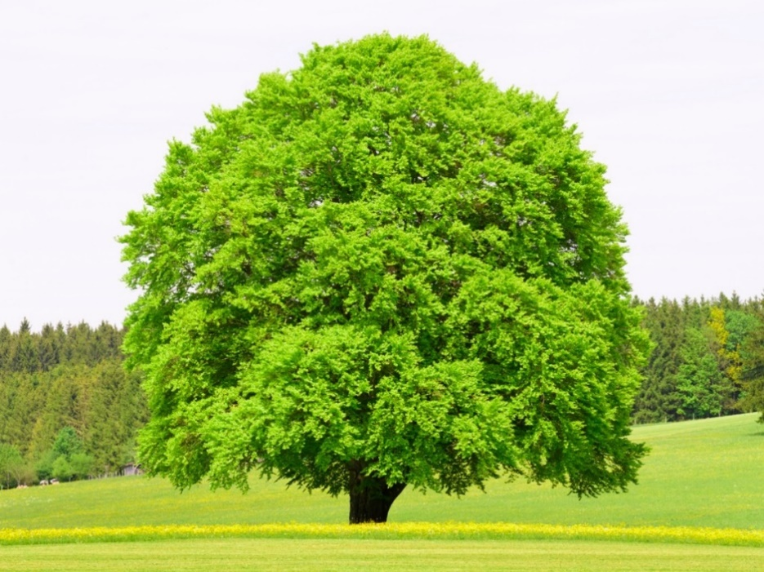

My new classroom is in the Junior side of the school. This is the same side that I am on now.

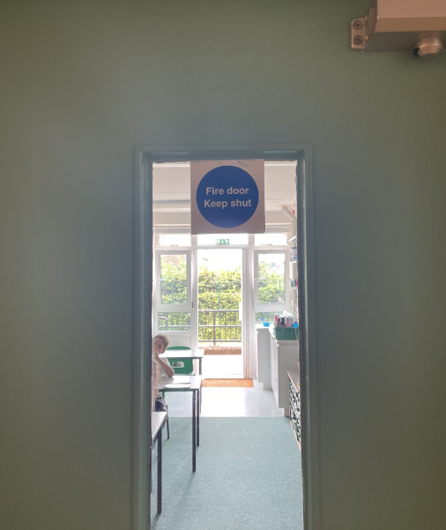

My new teachers will be Miss Cook and Mrs May. Miss Cook will be my teacher on a Monday, Tuesday and Wednesday. Mrs May will be my teacher on a Thursday and Friday.

 

Mrs Webb will be my Teaching Assistant. She will help me with my work and I can talk to her if I have any questions or problems, as well as my teachers.



I will come in the school through the junior gate and go straight to my classroom.

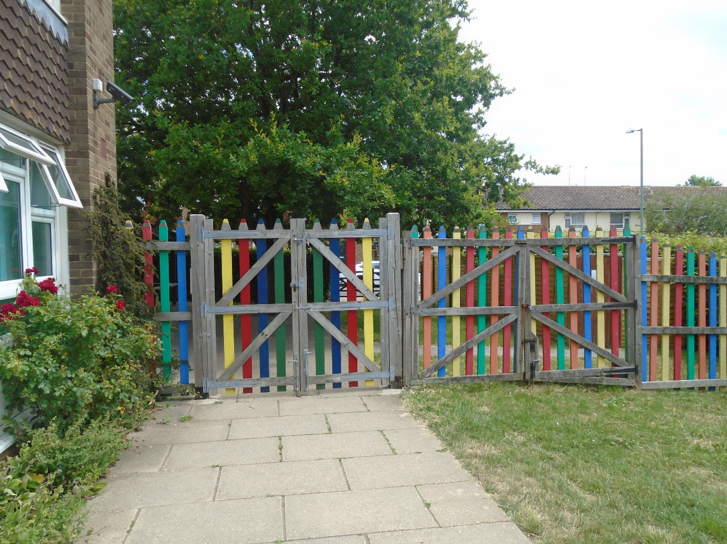

I will use the toilets and coat pegs along the corridor.

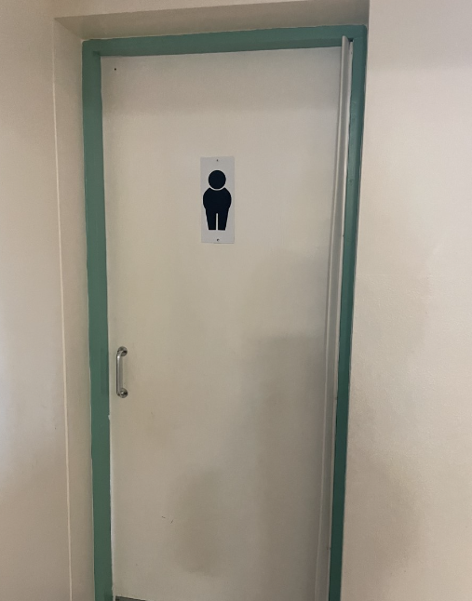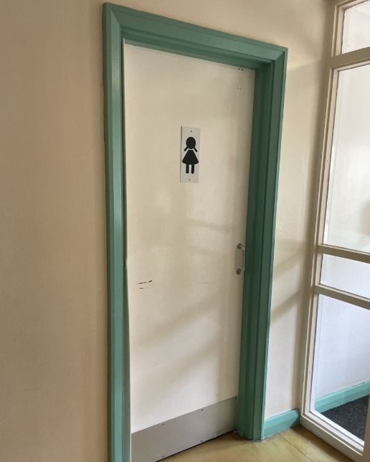

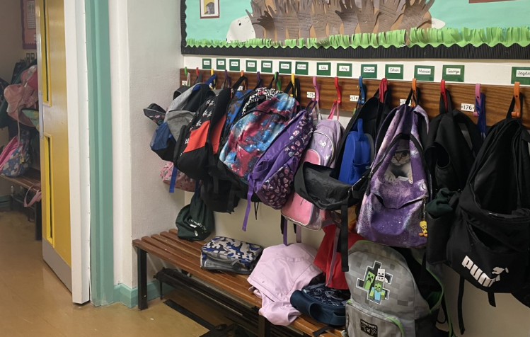

I will have break time on the Junior playground.

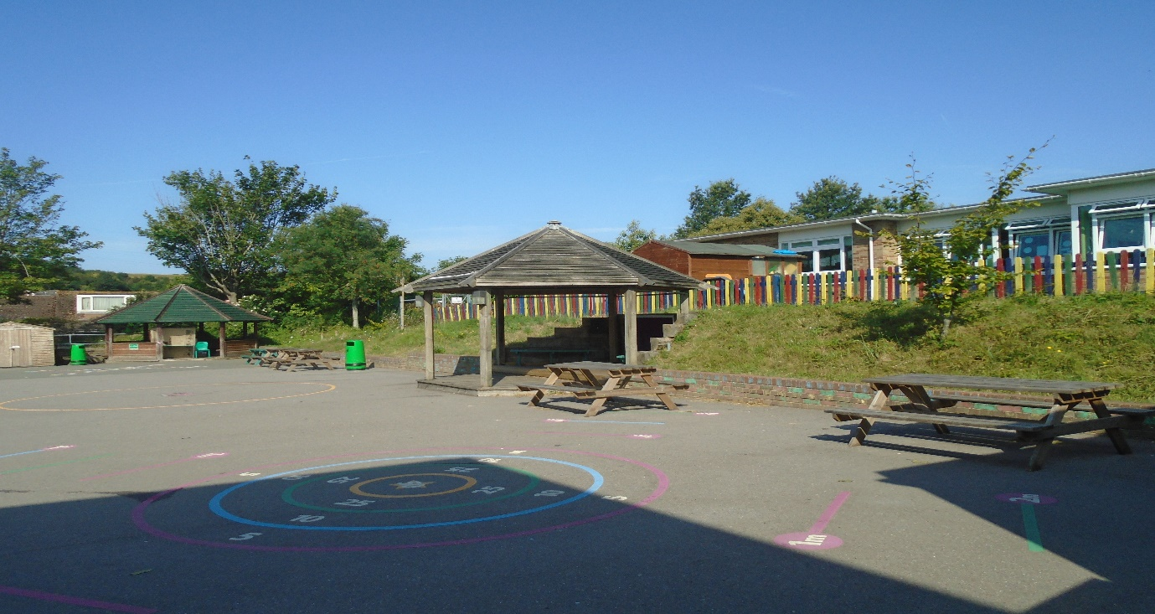

I will eat my lunch in the Junior hall.

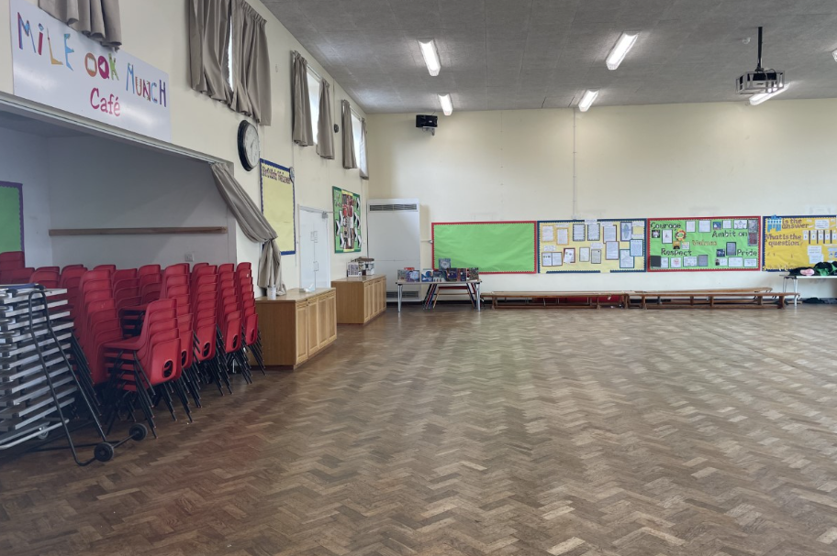

When school finishes at 3.20pm, I will meet my adult on the playground and leave through the Junior gate.

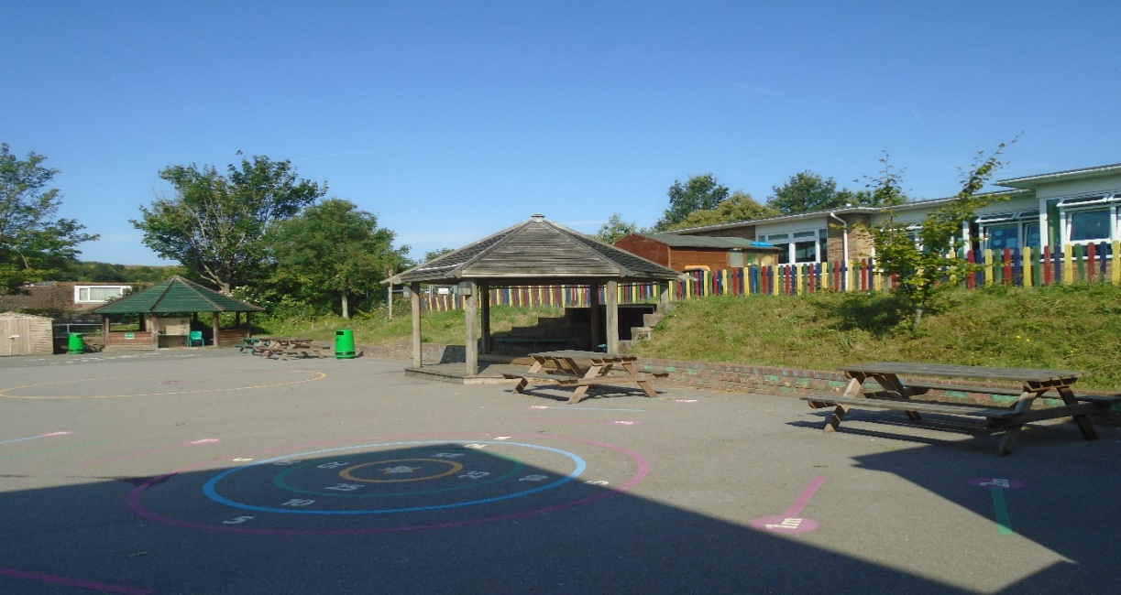

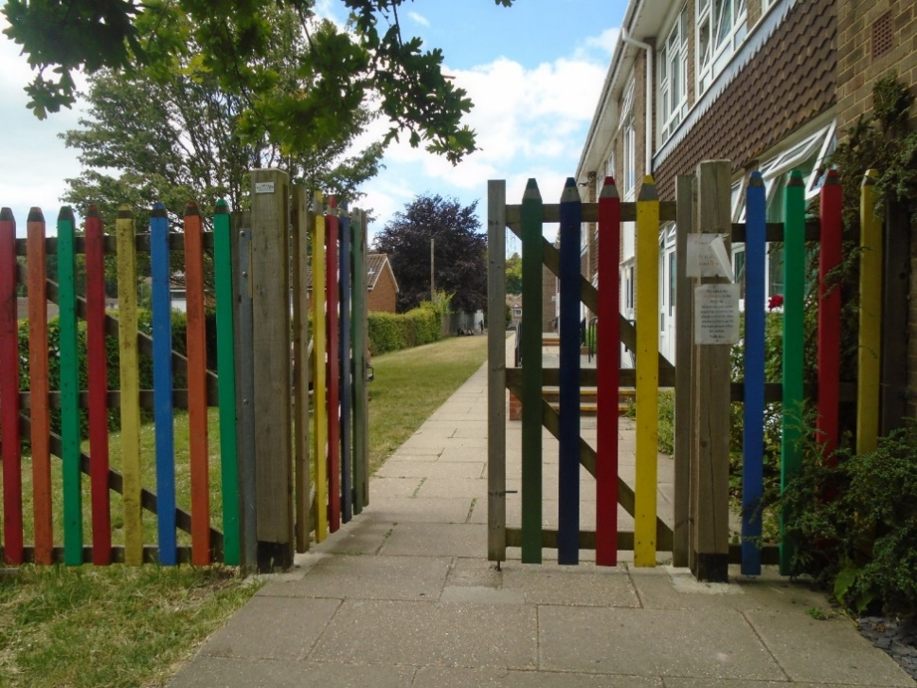

Welcome to Year 3!