Transition Booklet



Moving into Year 2

When I come back after the summer holiday, I will be in Year 2 with my new class.

My new class will be called Robin Class. A Robin is a type of bird.

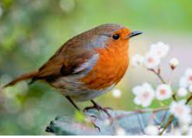

My new classroom is in the Junior side of the school.

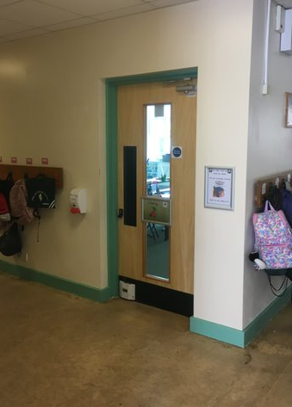

My new teacher will be Ms Griffiths.

This is Ms Griffiths.

Ms Rowe will be my Teaching Assistant(s). They will help me with my work and I can talk to them if I have any questions or problems.

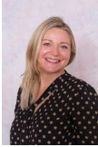

I will come in the school through the Infant gate and go straight to my classroom.

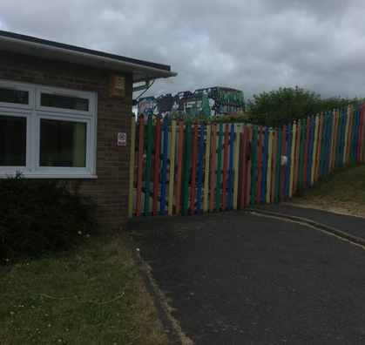

We will go through the hall, down these stairs and through this door to get to our classroom.

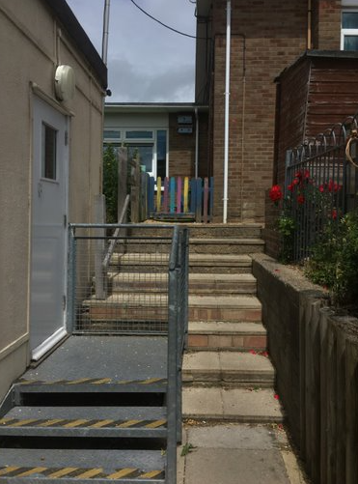

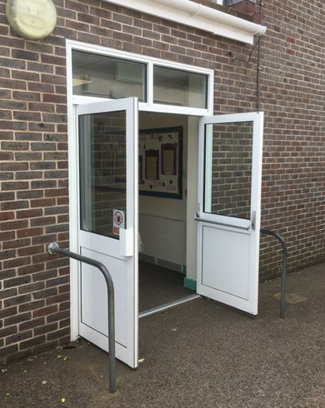

I will use the toilets and coat pegs along the corridor.

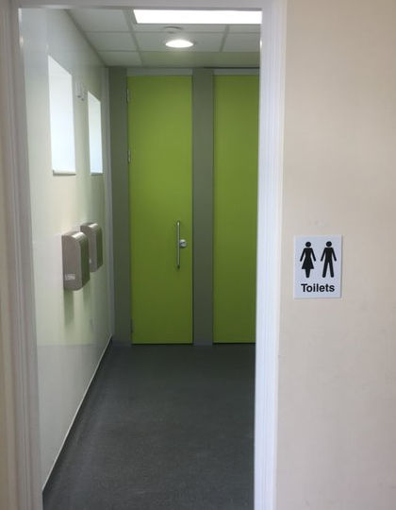

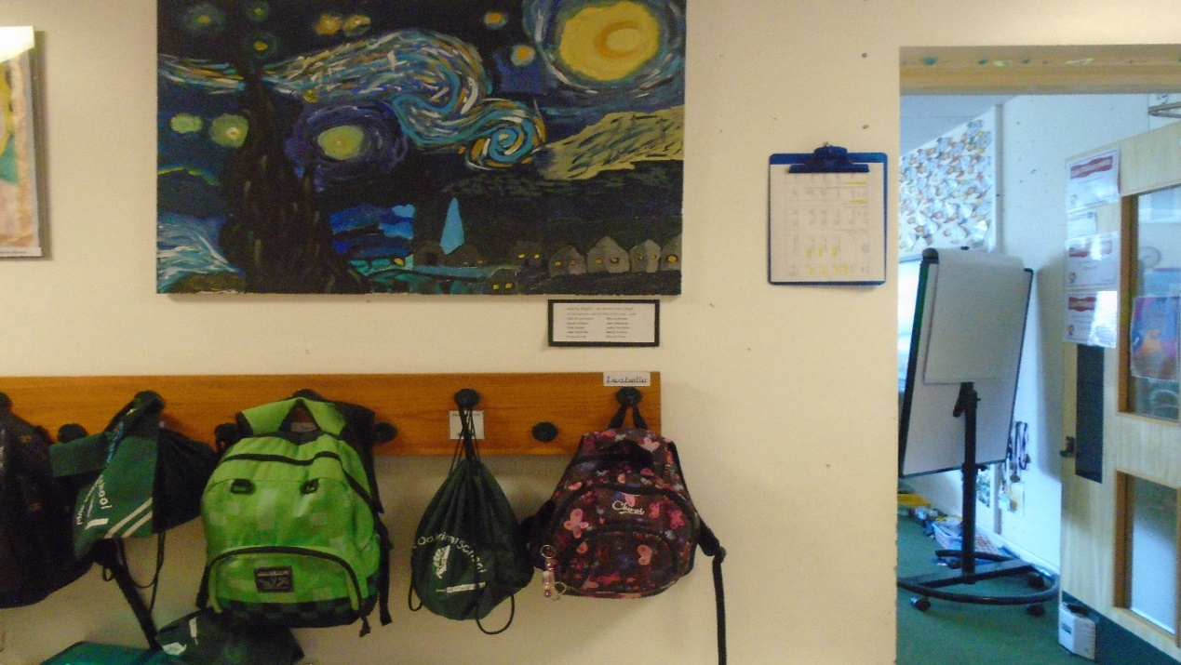I will have break time on the Infant playground.

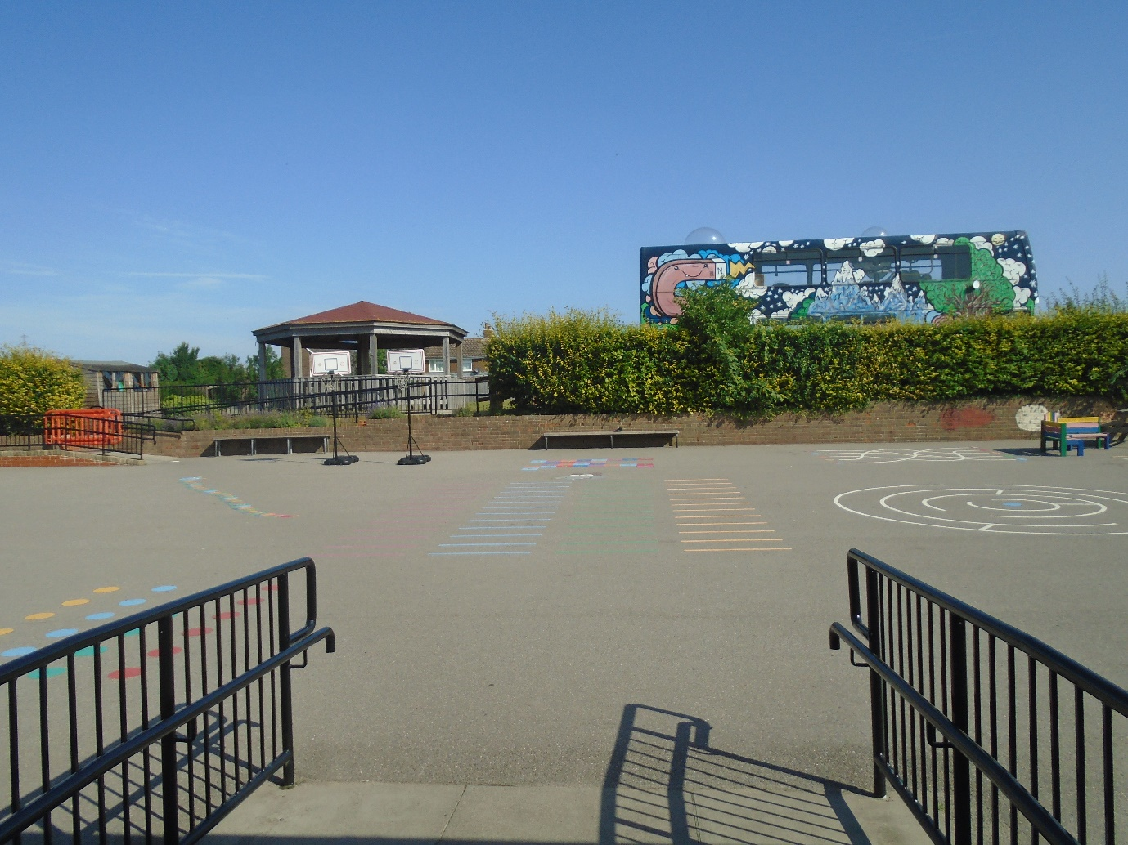

At lunch time I will go out onto the Infant playground first and wait until Year 2 are called into the Infant hall, where I will eat my lunch with my classmates.

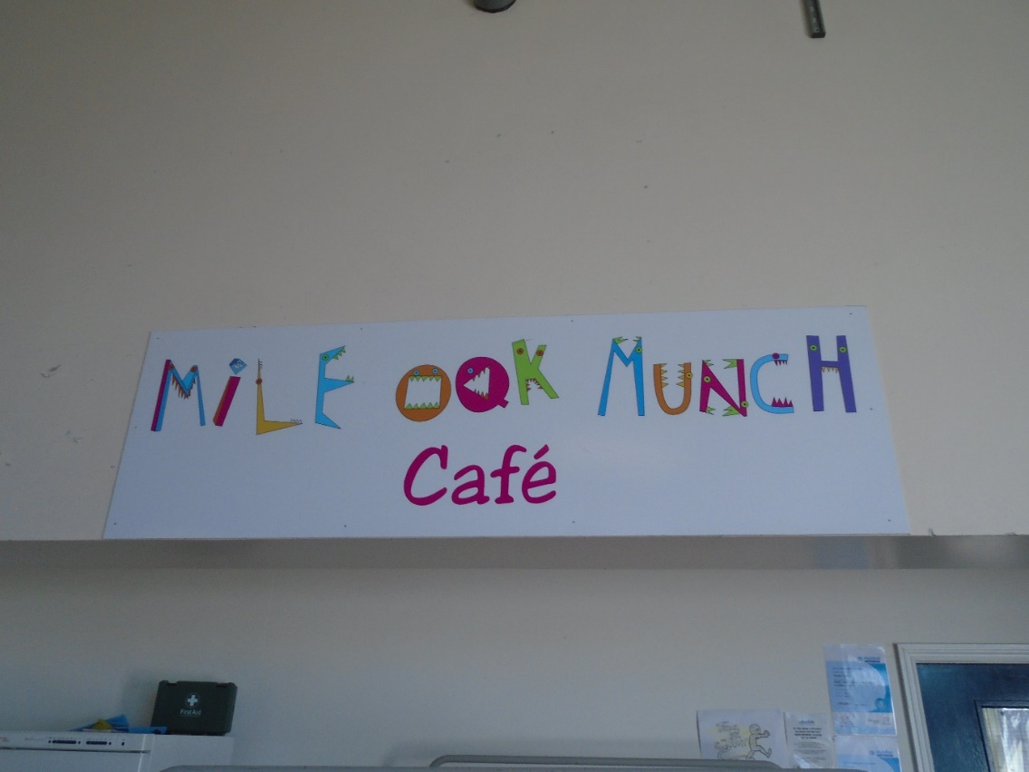

When school finishes at 3.15pm I will meet my adult on the playground and leave through the Junior gate.

